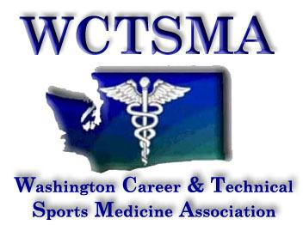

January 9th , 2018 (Tuesday, 6:00AM)
BOD Conference Call Agenda
Phone number: (888) 617-3400 pw 397051#

Members Present:

Motioned/seconded/approved to approve treasurer’s report
Motioned/seconded/approved October meeting minutes
Motioned/seconded/approved to move to meeting in the whole

Agenda:
- Spokane 2022
- Tri Tech Skills Center Kennewick Contract
- Test Update
- Hotels
- ED Meeting 1/19/18
- Civic Engagement Day 2/14-15/18
- Legislative Appointments 2/15/18
- SOT 5/20-23/18
- iGrant Status
- Program of Work Update
- Hotel Expectation on Behavior
- Chaperone Expectation During State Competition

Motioned/approved/seconded to move out of meeting of the whole
Meeting ended

ACTION ITEMS:

