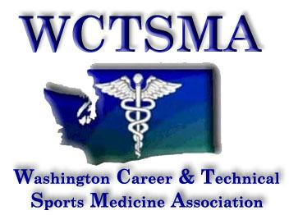

November 13th , 2018 (Tuesday, 6:00AM)
BOD Conference Call Agenda
Phone number: Google Hangouts

Members Present: Gary, Bud, Mariana, Julie, Heather, Jake, Larry, Ashley, Alexis
6:04 AM Motioned/seconded/approved to approve treasurer’s report
6:04 AM Motioned/seconded/approved October meeting minutes
6:05 AM Motioned/seconded/approved to move to meeting in the whole

Agenda:
- Winter leadership
  - 1 registration so far
  - State officers need to make sure to eat
- Membership update
  - 77 schools
  - 93 instructors
  - 6558 student members
  - $6510 in membership fees
  - Late fee on registrations
  - Certificates
- Anatomage partnership
  - Competition
- Advocacy day 1/13/19
  - Training is for officers only
  - Begins at 8:30 AM
  - Lobbying?
- State
  - Hotel sheet to being
  - Colin Henderson
- POW/POA
  - Extra funding available
  - Guidelines for districts and directors
  - $5000 must be used for leveraging training for statewide leadership community service development
- Student Meeting
  - Updates on student meetings
  - WL planning
  - Themes for WL

6:53 AM Motioned/approved/seconded to move out of meeting of the whole
6:55 AM Meeting ended

ACTION ITEMS:
Larry- start hotel sheet
All- register for state leadership
All- review POW

