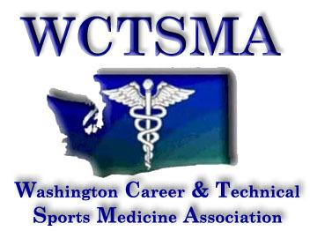

January 10, 2017 (Tuesday, 6 am)
BOD Conference Call Agenda
Phone number: (888) 617-3400 pw 397051#

Members Present: Tom Diimmel, Gary Clinton, Heather Sevier, Larry Howe, Chris Hiatt, Marianna Goheen, Kyanna Brenn, Graysen Kaess

Members Absent: Robin Backstrom

6:09 am Moved/Seconded/Approved to move into meeting as a whole
6:09 am Moved/Seconded/Approved to accept treasurers report

Agenda:
- Treasurer’s Report
- President
  - Key note speaker
    - Jake Locker cannot make it
    - Students working on new speaker
  - Hotel Policy notes
    - Emailed out this week for review, will be posted on website when finalized
  - State Schedule
    - Working with convention center to confirm locations and room names/numbers
    - BOD meet at state wrestling tournament to confirm and finalize
  - Test Updates
    - Heather – Med Terms (Jeff Kawaguchi)
    - Tom – Exercise Physiology (Garth)
    - Larry – talk to Joe and Josh on getting A and B section tests
    - Tests due March 1st
- Executive Director
  - Winter leadership
    - Made money since we were given a great deal on tickets
  - Spokane 2020
    - Working on finalizing hotel rooms and confirming pricing
  - State 2017
    - Added more rooms at Hotels
    - Sponsors – Henry Schein getting lanyards for us
    - Update website, forms, look at code of conduct
  - Civic engagement day
    - Larry getting more information on Friday
    - Dress in black pants, long sleeve, quarter zips

7:15 am Moved/Seconded/Approved to move out of meeting as a whole
7:15 am Meeting ended

