2018 Sports Medicine Educators Conference
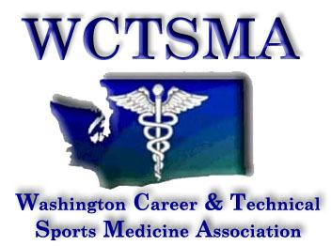
Sponsored by:

When: Friday, July 20, 2018
Where: University of Washington Jim Houston Board Room
http://www.gohuskies.com/ViewArticle.dbml?&DB_OEM_ID=30200&ATCLID=209987799
Who: Sports Medicine educators and CTE directors interested in starting programs
Time: Registration Opens 12:30pm. Class 1-5pm
Parking: South end of Husky Stadium, entrance is West Plaza of stadium
Clock Hours: Participants will receive 4 clock hours & 4 CEU’s if applicable

This educational opportunity is for instructors of the Sports Medicine specialty strand to network, share best practices, and better understand the issues surrounding instruction and supervision of their students. Those interested in starting up programs would also benefit from attendance. Instructors should also be encouraged to attend WA-ACTE & HSCTE Fall conference offerings.

A Few Session Topics (tentative)
- Navigating the NATA Secondary School Sports Medicine Sample Course Outline
- Update on the Curriculum Frameworks and OSPI Accountability
- Health Sciences Best Practices Lesson Sharing
- OSPI Health Sciences Pathway Supervisor support
- Professional Networking

REGISTRATION DEADLINE: Postmarked BY: Friday, July 6th

Registration Cost: (covers 2018-19 HSCTE dues, Clock Hours & CEU’s)
WCTSMA member instructor $80.00
Non-WCTSMA Member (2018-19 WCTSMA Instructor dues) $ 120.00
On-Site Registration (2018-19 WCTSMA Instructor dues, if applicable) $150.00

Complete and Mail Registration Form & Payment to:
WCTSMA
630 Valley Mall Pkwy #161
East Wenatchee, WA 98802

2018 Sports Medicine Educators Conference
*SCHEDULED FOR SAME WEEKEND AS WSATA STATE MEETING AT UW 7/21/18*
Sponsored by the WCTSMA

First Name _______________________
Last Name _______________________
Employer: ________________________
Position Title: __________________________
Course(s) taught: ____________________________________________________________________
Mailing address: _______________________________________________________
City: ______________________________ Zip: ______________
Email address: ___________________________________ Contact Phone: ( ) ___________

Registration Cost
____ WCTSMA Member $80.00

____ Non-WCTSMA Member (2018-19 WCTSMA Instructor dues) $120.00

____ On-Site Registration (2018-19 WCTSMA Instructor dues, if applicable) $150.00

*All participants will have their 2018-19 HSCTE dues paid along with 4 clock hours and 4 CEU’s

Total Cost: ______ Registration deadline, postmarked July 1th

Payment payable to WCTSMA

WCTSMA
630 Valley Mall Pkwy #161
East Wenatchee, WA 98802

***Payment may also be made by credit card online at www.wctsma.org***

