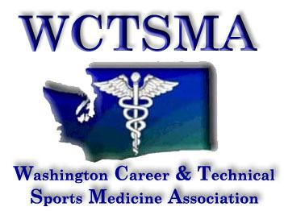

June 12th, 2018 (Tuesday, 6 am)
BOD Conference Call Agenda
Phone number: (888) 617-3400 pw 397051#

Members Present: Heather, Gary, Bud, Mariana, Ashley, Larry, Jake, Julie, Alexis

6:02AM: moved/seconded/approved minutes from previous meeting
: moved/seconded/approved treasurers report
6:03AM: moved/seconded/approved to move into meeting as a whole.

Agenda:
- Treasurer’s report
  - OSPI breakup of Perkin’s funds
  - Claimable vs. unclaimable activities
  - Approve report next meeting
- Nationals
  - 39 schools
  - 20 from WA
- Spokane 2022
  - $1000 downpayment to reserve date, followed by $1000 next year
  - New date?
- Tacoma 2019
  - Working with sports commission
  - Social in the works
- BOD Retreat
  - 7/20 @9:00AM
- Summer Ed Conference
  - Registration update
- Coaches School
  - Gary, Bud, Julie, Jake, Larry
  - Recruit other members
- No Puyallup SD fundraiser
- Monthly Student Leadership Meeting 1st Sunday 8pm next 7/8/18
- Fall Leadership
  - Rundown of event
  - 14 schools expressed interest
  - Max number?
  - Registration- defer to the Sounders but maintain counts
  - Payment info
  - Code of conduct
  - 9/19 registration deadline
  - Insurance?
- Winter Leadership
  - Good chance of a game on 12/5
- Summer Conference
  - Issues with registration
  - Extra charges
  - Sending students
  - OSPI questions about new costs
- Civic Engagement-New Market after
  - Reception/banquet at New Market?
- WSCA
  - Registration is open
- SL Face-to-face
  - Determine whether or not it is going to happen
- New method for meetings
  - Google Meet?

6:59AM: moved/seconded/approved to move out of meeting as a whole
7:00AM: meeting ended
Action Items:
Work on claimable vs. unclaimable items- everyone
Continue working on stuff for educator’s conference- everyone

