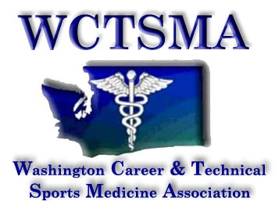

September 9, 2014 (Tuesday, 6 am)
BOD Conference Call Agenda
Phone number: (888) 617-3400 pw 397051#

members present: Angela Bushmaker, Gary Clinton, Tom Dimmel, Larry Howe, Marianna Goheen, McKenna P., Erin V., Chris Hiatt
Members Absent: None

6:03 Call to order
6:06 moved/seconded/approved to start meeting as a whole
6:05 moved/seconded/approved to accept treasury report and table July BOD retreat 2014 minutes

Agenda:
- Treasurers Report (Gary)
- Minutes from BOD Retreat
- Executive Director Report
  - Old Business:
    - Summer Leadership - 40 students
    - Coaches School - CPR 61, raised $3400
    - HSCTE - Conference Oct 10, 2014
    - WSCA - members sign up as WCTSMA members
  - New Business:
    - Fall Kick-Offs
      - Moses Lake 9/22 Monday MLHS 10-1pm Inland NW Blood Center
      - FW - Angelina working on finding location
      - Everett - Nick working on Blood Buses at a school location, 9/24 or 10/1
    - Membership Update - 2 members currently, sending out more reminders
    - Winter Leadership
      - Space set
      - WinForum? have them as speakers?
      - Other Speakers - Huan Do, Silvertips ATC?
    - State Speakers - Beau Baldwin?, Darmony Jones?
    - Medco Partnership/Corporate Advisory
    - OSPI/CTSO Directors meeting 9/29/14
    - Contract Updates
      - 2017 Spokane-Davenport hotel?
      - 2016 TriCities
    - Welcome Mailing - from student presidents and Angela
    - Apple PT Opportunity-Marianna email - They’re interested in setting up a practicum opportunity for students. More information to come.
- WSATA Update – Chris
  - BOD talking points for Craig to discuss with OSPI, but ultimately WSATA Secondary School Committee is responsible for the recommendation
    - Clearly define what the student responsibilities are
- By-Laws – Angela/McKenna - working on aligning it with student organization

7:11 moved/seconded/approved to leave the meeting

Action Items:

7:11 meeting adjourned

October 14, 2014 next meeting

