25th annual Spring Symposium and State Competition Tacoma, WA. April 18-20, 2019

Hotel Information Sheet
Hotel Murano

Hotel Murano
1320 Broadway Plaza
Tacoma, Washington 98402
Main phone (253) 238-8000
Fax (253) 627-3167
Toll Free: 888-862-3255
www.hotelmuranotacoma.com
King Deluxe $159.00 $159.00 $169.00 $179.00 Quad
Double Double Deluxe $159.00 $159.00 $169.00 $179.00 Quad
https://gc.synxis.com/rez.aspx?Hotel=76784&Chain=21650&arrive=4/18/2019&depart=4/21/2019&adult=1&child=0&group=0713343

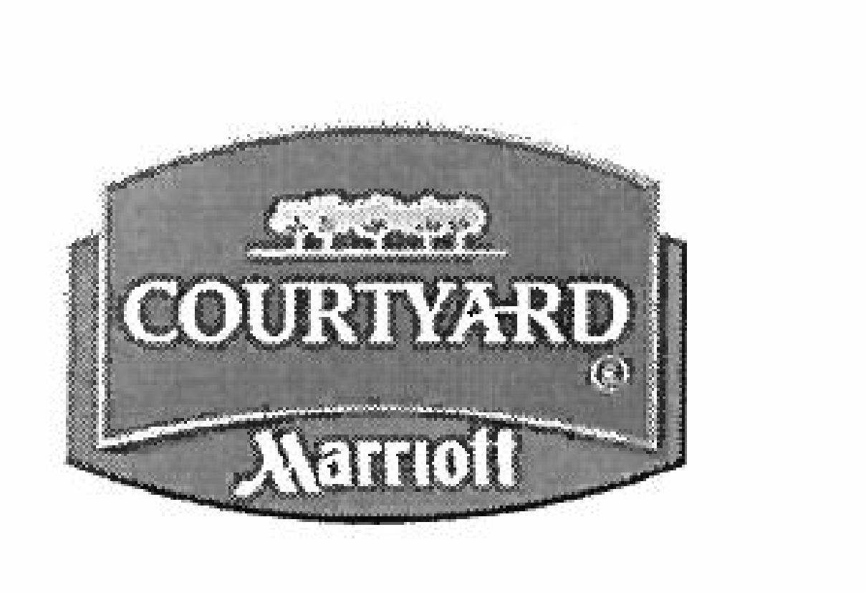

http://www.marriott.com/hotels/travel/seatd-courtyard-tacoma-downtown/
Courtyard Tacoma Downtown
1515 Commerce Street Tacoma Washington 98402 USA
253-591-9100
Here is your online reservation link: all rooms $179
WCTSMA Spring Symposium / Competition
***Please contact Larry Howe, Executive Director if you are unable to secure rooms for WCTSMA****

