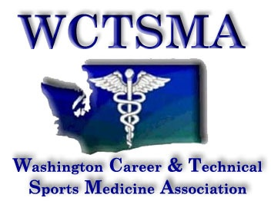

Henry Schein Sports Medicine Division
As determined by the WIAA 2016-2020 enrollment numbers
Lakes 1055 North Kitsap 810
Lynwood 1002 Centralia 809
Central Kitsap 1012 Cedarcrest 716
Enumclaw 974 East Valley 656
Bainbridge 957 Kingston 604
Franklin Pierce 924 Lynden 601
Cheney 905 Orting 554
Liberty 878 North Mason 527
Sehome 867 Klahowya 445
Olympic 863 Sultan 347
Bremerton 863 YV Tech
River Ridge 834 23 Schools

