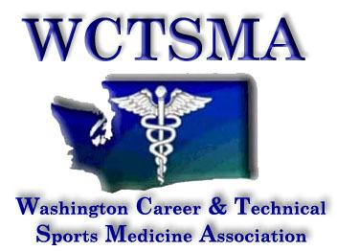
WCTSMA
April 20, 2019
General Membership/Business Meeting
8:15-9:15am

- Agenda
  - Begins at 8:24 AM
- Call to order
- Treasurer’s Report
- Secretary’s Report
  - Ballroom A should be Exhibition hall A
  - 880 registered
  - 53 schools
  - 75 member schools
  - 6984 students
- Student Leadership Report
  - Info on state president voting
  - May State Officer Training 5/19-21/19 Black Lake
  - Legislative Day 2/20-21/20--- CTE Day
  - Fall Leadership 10/6/19 Century link---- Sunday- new speakers, new space
  - Winter Leadership 12/18/19 Angel of the Wind Everett- later than usual
- Executive Director
  - Civic Engagement Day 2/20-21/20- OVERNIGHT for officers this yar
  - National Sports Medicine Competition May 16-17, 20-21, 2019
    - Three teams already qualified
  - Be sure to fill out student and instructor feedback forms
  - State Officer Training May 19-21, 2019 Black Lake
  - Educators conference July 19th at the University of Washington - big fundraiser for our scholarships as well.
    - Friday before state meeting
  - Coaches school - July 25 Thursday - need more instructor help as well
  - Register early for instructor dues to cover liability
  - Fall Leadership 10/6/19 Century Link
  - Winter Leadership - December 18, 2019 Wednesday in Everett
  - State 2020 - Spokane 4/23-25 RLR/Grand
  - Transcripts/deadlines
    - Don’t email before checking with a counselor
    - Only varsity
- Vice President
  - Student Rep e-mails
    - How to use…
- Other /New Business
  - Members Thoughts and Questions?
  - Add “no vaping” to student Code of Conduct
- Voting items:
- Treasurer Position
  - Gary Clinton won

