WCTSMA Winter Leadership Conference
When? Wednesday, December 6, 2017 From 12:00 – 4:30 PM
Where? Xfinity Center at Everett, WA
How Much? WCTSMA Student Members $25.00; Non-Members Students $30.00. Instructors and Chaperones $16 for hockey game tickets. Non-Hockey game $10
How do I sign up?
Prior to November 17th, E-mail a copy of this form to llhowe2@yahoo.com, then mail a copy of this registration form with complete payment to WCTSMA, 630 Valley Mall Pkwy #161, East Wenatchee, WA 98802. No PO’s will be accepted. Only checks payable to WCTSMA or cash will be accepted. Any changes in name or number of attendees must be emailed prior to the conference. Credit Card payment is available now on the website.
All late or on-site payments will be assessed a $5/participant fees for administration costs.
Conference/Program
Check-In will start at 11:30am. Students will participate in leadership activities throughout the day. We will break for dinner and return to the hockey game that evening at 7pm. Instructors and chaperones please include $16 for each person planning on attending the hockey game. On site payments will be assessed a $5/participant late fee including advisers/guests.
Winter Leadership Conference Directors:
Chris Hiatt, State Officer Director
State Co- Presidents & the State Officers
Larry Howe, WCTSMA Executive Director
Questions:
Any questions or concerns may be emailed to: llhowe2@yahoo.com.
Conference Sponsor:

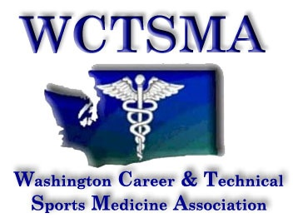

REGISTRATION
2017 Winter Leadership Conference
Xfinity Center Everett,WA.
Wednesday, December 6, 2017

How to Register:
E-mail a copy of this form to llhowe2@yahoo.com by November 17th and then print and mail a copy of this registration form with complete payment to WCTSMA, 630 Valley Mall Pkwy #161, East Wenatchee, WA.98802. No PO’s will be accepted. Only checks payable to WCTSMA or cash will be accepted. Any changes in name or number of attendees must be emailed prior to the conference. All late or on-site payments will be assessed a $5/participant fees for administration costs. Code of conduct and medical release paperwork is required for this event as all WCTSMA events. Advisers are responsible to show proof of compliance.

School:

Instructor(s):

Contact E-Mail: Contact Phone Number:

Chaperone(s) (in addition to instructor):

We will be traveling in a: Bus Vans Other

Our school is: WCTSMA Members ($25.00/student) Membership #
Non-Members ($30.00 per student)
*Instructor please include $16 for yourself/chaperones/bus drivers that would like to attend the hockey game*
* Students not attending hockey game will be $10*
Name of Students: (First / Last)

1.
2.
3.
4.
5.
6.
7.
8.
9.
10.
11.
12.
13.
14.
15.
16.
17.
18.
19.
20.
21.
22.
23.
24.
25.
26.
27.
28.
29.
30.

