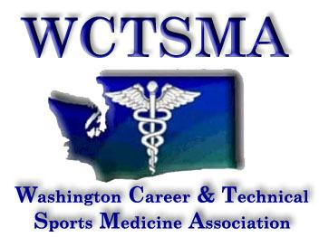
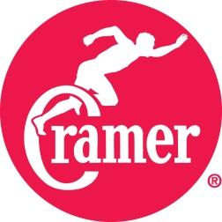
WCTSMA
April 15, 2016
General Membership Meeting
8:15-9:15

- Agenda
- Call to order
  - 8:24 am Motion by Denton Norwood, Second by Angela Bushmaker
- Reports:
- Treasurer’s (Dollar totals)
  - Handed out treasurers report
  - Coaches schools are biggest fundraiser for scholarships, we need more instructor support for those events
  - CTSO funding - Marianna Goheen
- Secretary (Membership & competition #’s)
  - Membership
    - 74 member schools
    - 5500 student members
    - 3rd largest CTSO
  - Competition
    - 48 schools
    - 796 students competing
- Student Leadership (State Officer training, Legislative & WA-ACTE activities)
  - May State officer training - Warm Beach, Stanwood
  - Legislative Day in February
  - WA-ACTE in August
  - Need more involvement with student leaders from Eastern Washington
  - As we grow possibility of moving to larger format with regional officers, etc.
  - Look at all social media aspects for student information
- Executive Director (CTSO group work & business partnerships)
  - Civic Engagement day - February 15, 2018
  - National Sports Medicine Competition
  - State officer training - Tri Leadership coming in to work with students.
  - Be sure to fill out student and instructor feedback forms
  - Coaches school express - June 10 - need more instructor help
  - Educators conference July 14 at the University of Washington - big fundraiser for our scholarships as well.
  - Coaches school - July 27 - need more instructor help as well
  - Register early for instructor dues to cover liability
  - Winter Leadership - December in Everett
  - State 2018 - TriCities, 2019 Tacoma
9:23 am - adjourned
1:00 Resume instructor meeting
1:10 am Denton Norwood Called to order, Kyle Lougherty seconded

- Discussion Items
- Educators Conference 2017
- Summer Leadership 2017
- Winter Leadership 2017
- Spring Symposium/Competition, Tri-Cities 2018
- Competition rotation cycle
- Any hotel information/complaints please forward on to Tom Diimmel so that he can send them to the director of the convention center.
- Hotel contracts - have more stipulations on what needs to be included on the hotel end

- Other /New Business
- NHSSMA / NHSSM Membership

- Voting items:
- Secretary

Discussion items:

- Curfew time added to the code of conduct so they are the same across the board - no differences between school to school
- Look into how to handle IEP/504 plan students
- Put copies of O/P questions out for the student to read during testing
- O/P proctor issues
- Possibly have list of O/P type questions that could be on the test for students to look at beforehand.
- NATA secondary school standards have to be included in Frameworks
Denton Norwood moves to vote on secretary position

